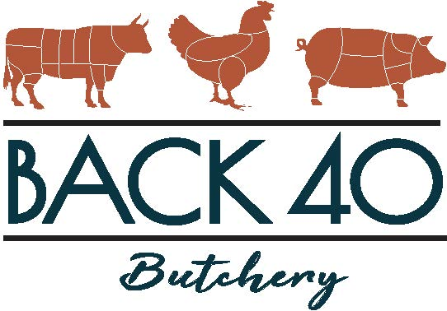

Beef Processing Prices
Effective January 1, 2023
Slaughter Fee $95.00
(If purchasing half beef $47.50)

Basic Processing Fee by Dress Weight - $1.35/lb
Basic Processing Fee by Dress Weight-USDA Labeled for Re-Sale -$1.55/lb
*$0.30/lb for boneless or single packaged steaks
*$0.60/lb for cubed steak, beef stew, fajita strips or kabobs
*$1.00/lb for sliced liver
*Standard Ground Beef packaging is 1.5lb or 2lb packages – 1lb packages are available for an additional $0.15/lb
*Standard cuts are listed on beef cut sheet, any special cuts requested may occur additional charges.

If purchasing less than a whole beef there is a split charge of $25.00 per split, for example, half beef will be a $25.00 charge for each half. If you request beef to be separated into quarters it will be $25.00 per quarter.

***There is a $500.00 minimum processing charge for each beef***

